Docker challenge.

1: Create a customized Docker image using a Docker file.
Steps
Step 1: Create a project directory
mkdir custom-docker-image
cd custom-docker-image
Step 2: Create a custom HTML page
nano index.html
Add the following content:
<h1>Hello from My Custom Docker Image!</h1>
<p>Created using a Dockerfile.</p>
<p>Docker Challenge 1 Completed.</p>
Save: Ctrl + O → Enter → Ctrl + X.
Step 3: Create a Dockerfile
nano Dockerfile
Add:
FROM nginx:latest
COPY index.html /usr/share/nginx/html/index.html
EXPOSE 80
Step 4: Build the custom image
docker build -t my-custom-nginx:v1 .
Step 5: Verify the image
docker images
Step 6: Run the container
docker run -d --name custom-nginx-container -p 8083:80 my-custom-nginx:v1
Step 7: Verify the running container
docker ps
Step 8: Test the webpage
curl http://localhost:8083

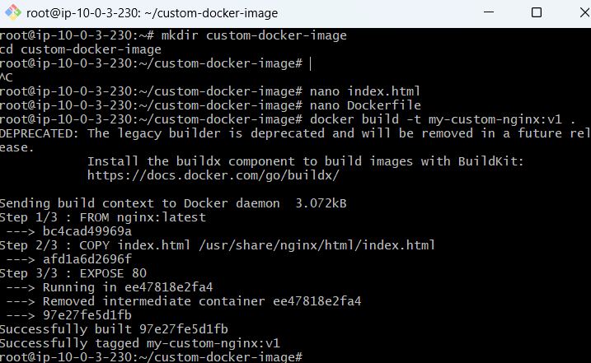
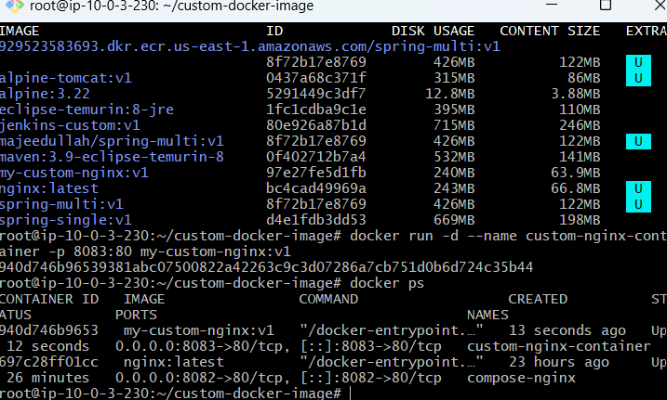
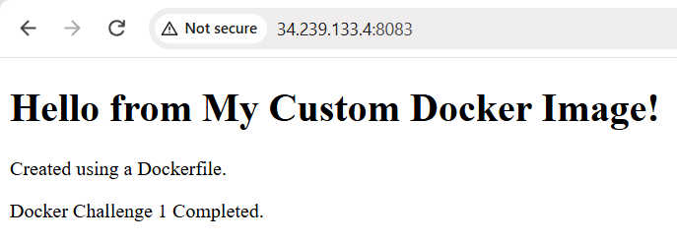
2: Push the image to Docker Hub.
Steps and notes — Challenge 2
- Verified the custom image using docker images.
- Logged in to Docker Hub using docker login.
- Tagged the image for Docker Hub:
docker tag my-custom-nginx:v1 majeedullah/my-custom-nginx:v1
- Pushed the image:
docker push majeedullah/my-custom-nginx:v1
- Verified the repository and v1 tag on Docker Hub.
Command | Purpose
docker login | - Authenticates with Docker Hub
docker tag | - Assigns the Docker Hub repository name
docker push | - Uploads the image to Docker Hub
docker pull | - Downloads the published image

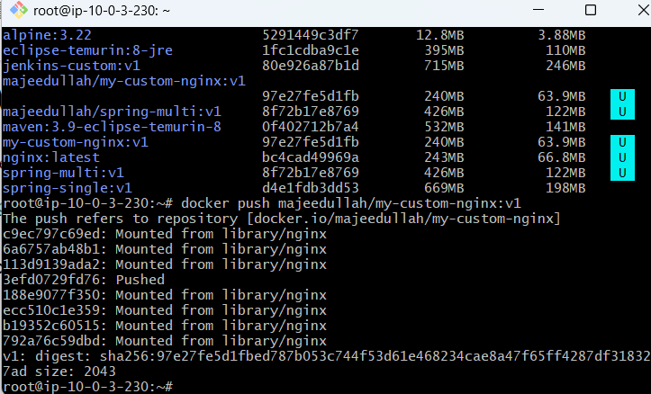
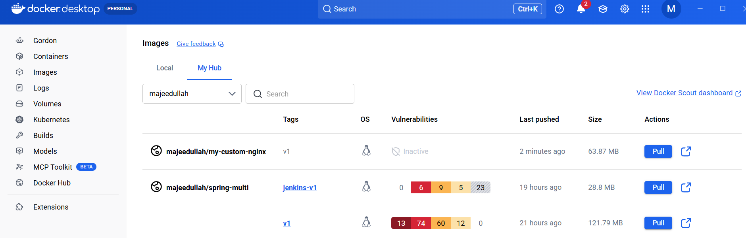
3: Push the same image to Amazon ECR
What is ECR? Amazon ECR is AWS's private container image registry. It stores Docker images so they can be used by services such as EC2, ECS, and EKS
Steps and notes — Challenge 3
- Checked AWS CLI installation using aws --version.
- Verified the AWS account using aws sts get-caller-identity.
- Logged in to ECR using aws ecr get-login-password.
- Tagged the existing image with the ECR repository URI.
- Pushed the image using docker push.
- Verified the uploaded image using aws ecr describe-images.
- Confirmed tag v1 in the AWS Console.
Important commands
aws ecr get-login-password --region us-east-1 | docker login --username AWS --password-stdin 929523583693.dkr.ecr.us-east-1.amazonaws.com
docker tag my-custom-nginx:v1 929523583693.dkr.ecr.us-east-1.amazonaws.com/my-custom-nginx:v1
docker push 929523583693.dkr.ecr.us-east-1.amazonaws.com/my-custom-nginx:v1
Interview note: Amazon ECR is a managed container registry used to store, manage, and deploy Docker images within AWS.
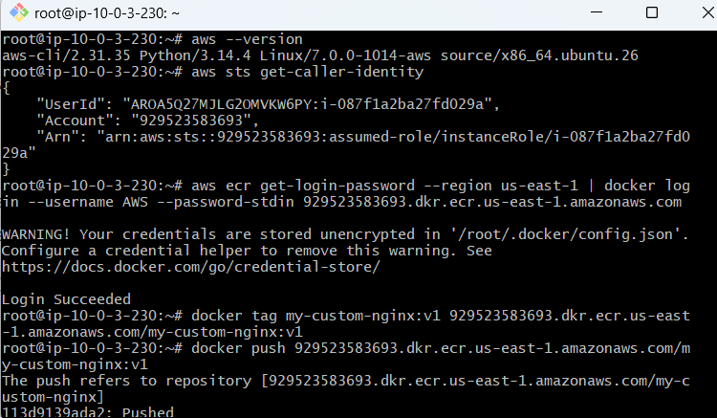
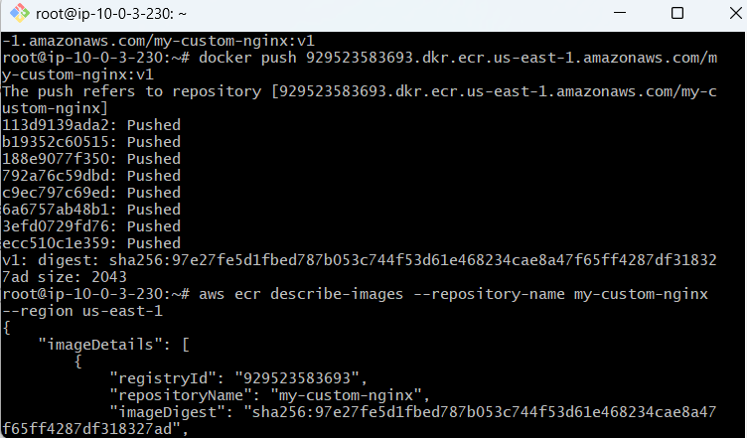
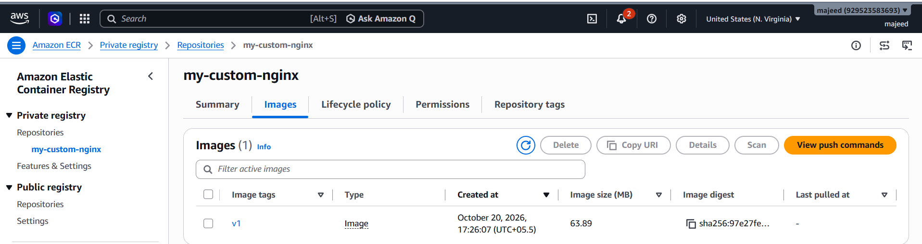
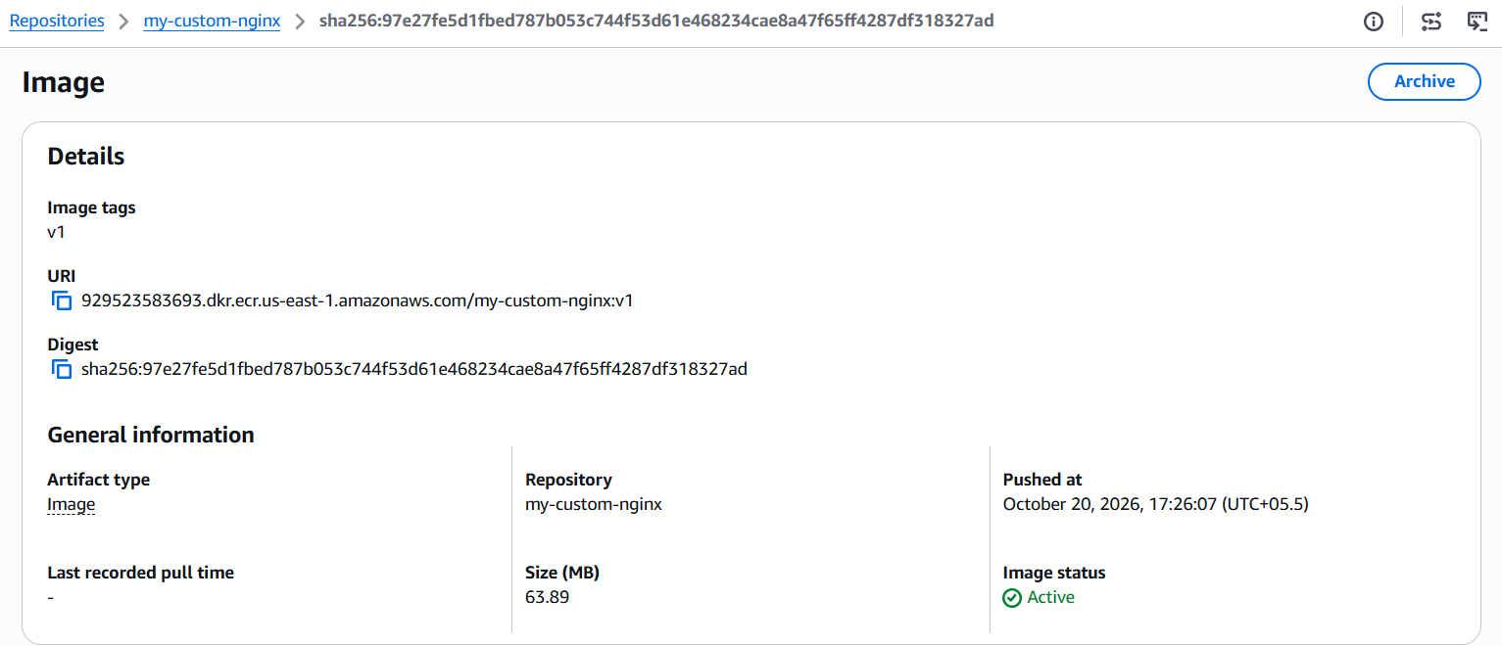

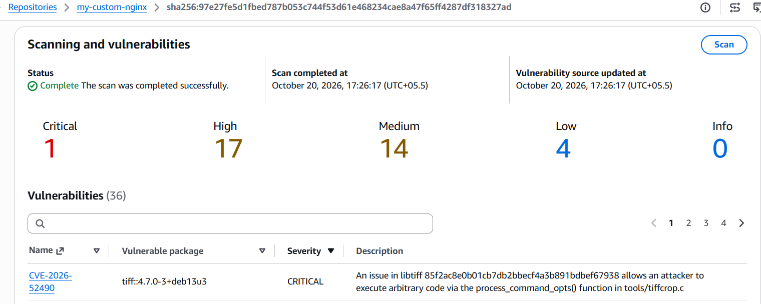

4: Provision one EC2 instance using Terraform and install Jenkins.
Steps performed
- Installed Terraform on Windows
  - Downloaded Terraform for Windows AMD64.
  - Added C:\terraform to the PATH.
  - Verified using terraform -version.
- Configured AWS
  - Used AWS CLI credentials to connect Terraform to AWS.
  - Set the AWS region to us-east-1.
- Created main.tf
  - Configured the AWS provider.
  - Defined a security group allowing SSH (22) and Jenkins (8080) from my IP.
  - Configured an EC2 instance using Ubuntu, instance type t3.small, and key pair khan.
  - Selected the existing VPC and subnet.
- Initialized and validated Terraform
- terraform init
- terraform fmt
terraform validate
  - init: Downloads the AWS provider.
  - fmt: Formats the Terraform configuration.
  - validate: Checks configuration syntax.
- Reviewed the execution plan
terraform plan
Confirmed that Terraform planned to create two resources without changing or destroying existing resources.
- Provisioned the resources
terraform apply
Typed yes when prompted.
Result: 2 added, 0 changed, 0 destroyed.
- Installed Jenkins automatically
  - Used the EC2 user_data script to install Java 21 and Jenkins.
  - Enabled and started the Jenkins service.
- Verified Jenkins
  - Opened http://44.211.143.16:8080/.
  - Confirmed the Jenkins dashboard was accessible.
  - Verified that the Jenkins service was active (running) and Java 21 was installed.
Important resource details
Resource | Value
EC2 instance ID | i-02a167b30032ce6f3
Instance type | t3.small
Public IP | 44.211.143.16
Private IP | 10.0.3.123
Region | us-east-1
Security group | sg-0577caa8ce7f063a4
Jenkins port | 8080
Jenkins status | Active (running)
Short study notes
- Terraform: Infrastructure as Code (IaC) tool used to create and manage AWS resources.
- main.tf: Terraform configuration file defining the resources.
- AWS provider: Allows Terraform to communicate with AWS.
- aws_instance: Creates an EC2 instance.
- aws_security_group: Controls inbound and outbound network traffic.
- user_data: Runs a startup script to automate software installation.
- terraform plan: Previews proposed changes.
- terraform apply: Creates or updates the configured resources.
- Jenkins: Automation server used for CI/CD pipelines.
Final result: Terraform successfully provisioned an EC2 instance and automated the installation of Jenkins. The Jenkins dashboard is accessible through the browser

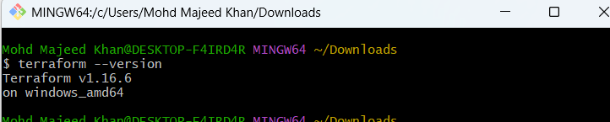
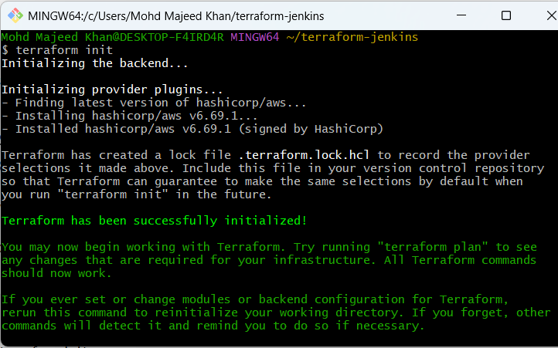
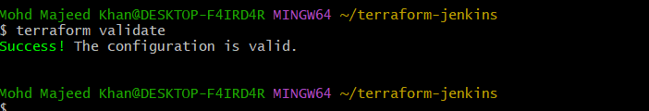
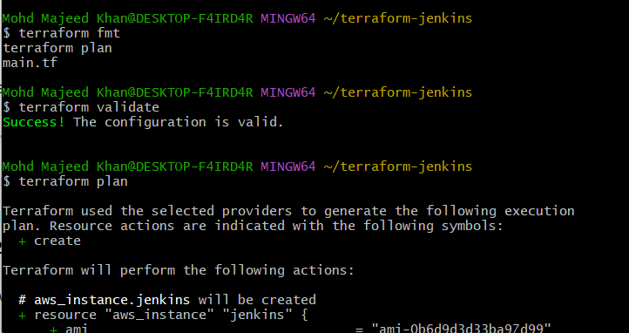
Terraform plan shows:
Plan: 2 to add, 0 to change, 0 to destroy.
Terraform plans to create:
- Security group — terraform-jenkins-sg
- EC2 instance — Terraform-Jenkins-Server

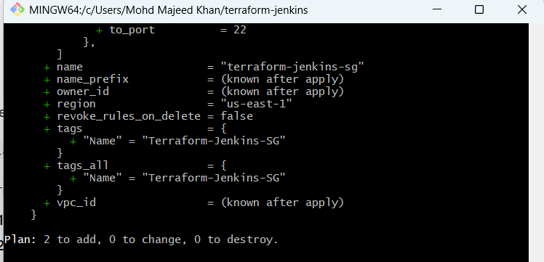
terraform apply {command}: Terraform successfully created your Jenkins EC2 server.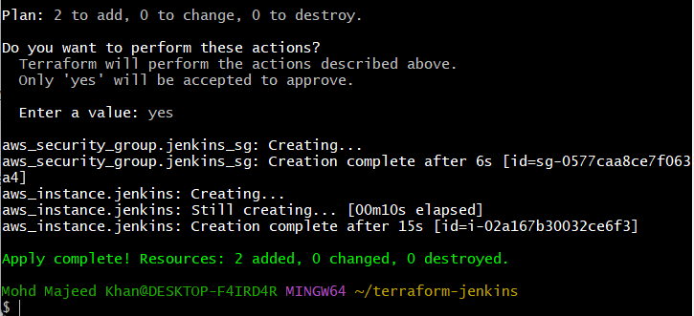
aws ec2 describe-instances \
--instance-ids i-02a167b30032ce6f3 \
--region us-east-1 \
--query 'Reservations[0].Instances[0].[State.Name,PublicIpAddress,PrivateIpAddress]' \
--output table
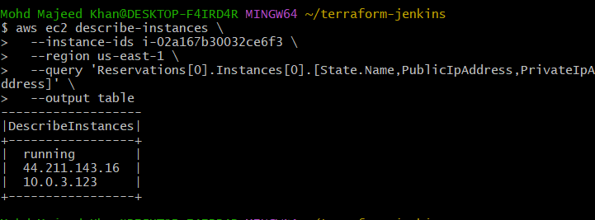
Your Terraform-created EC2 instance is running.
- Instance ID: i-02a167b30032ce6f3
- Public IP: 44.211.143.16
- Private IP: 10.0.3.123
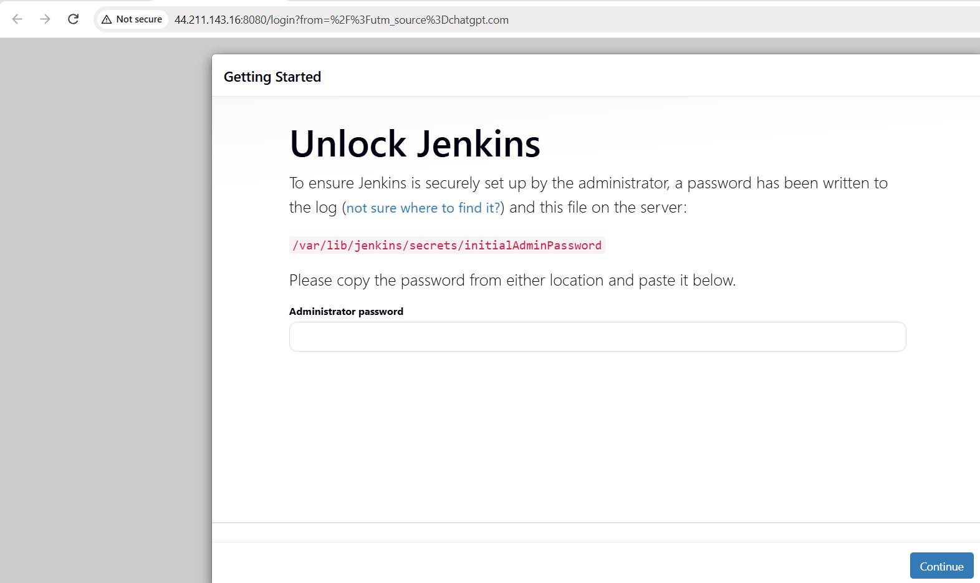
ssh -i "$HOME/Downloads/khan.pem" ubuntu@44.211.143.16
Retrieve the password
After you connect and see the Ubuntu server prompt, run:
sudo cat /var/lib/jenkins/secrets/initialAdminPassword

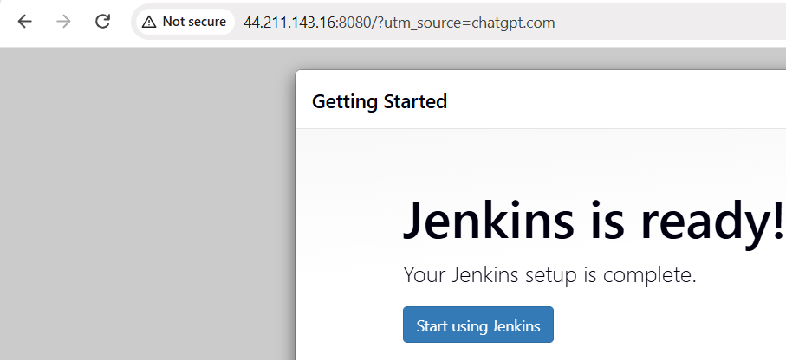
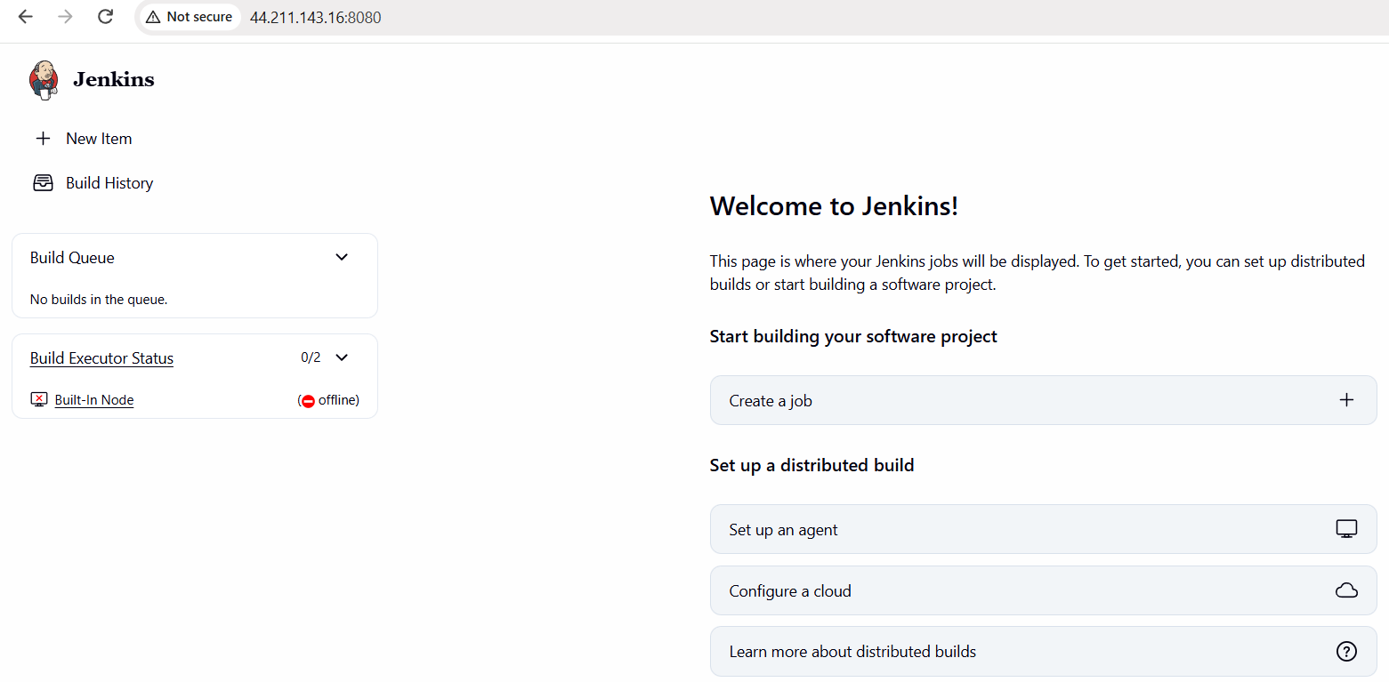
5.Create one Jenkins job to build and push the Docker image to Docker Hub.
  - Source: https://github.com/betawins/Python-app.git
Source Codes: https://github.com/betawins/docker-tasks.git
- From the frontend source code, write a Dockerfile, build a Docker image, run it, and push that image to your Docker registry.
- From the Java-based source code, write a Dockerfile, build, run, and push the image to the Docker registry.
- From the Node.js-based source code, write a Dockerfile, build with tag v1, run, and push it to the Docker registry.
- Write a docker-compose file to set up WordPress with a MySQL database
- Source repository: Python-app
- Jenkins job: python-app-dockerhub-pipeline
- Goal: Use Jenkins to download the source code, build a Docker image, test the container, and push the image to Docker Hub.

Steps completed
Step | Action | Result
1 | Created a Jenkins pipeline job | python-app-dockerhub-pipeline
2 | Checked out the GitHub repository | Source downloaded
3 | Built the Docker image | majeedullah/python-app:1
4 | Ran and tested the container | Flask application started on port 8080 inside the container
5 | Logged in using Jenkins Docker Hub credentials | Login succeeded
6 | Pushed the image to Docker Hub | Tags 1 and latest pushed
7 | Removed the test container | Cleanup completed

Main pipeline commands
- docker build -t majeedullah/python-app:1 .
- docker run -d --name python-app-test -p 18080:8080 majeedullah/python-app:1
- docker push majeedullah/python-app:1
- docker tag majeedullah/python-app:1 majeedullah/python-app:latest
- docker push majeedullah/python-app:latest
- The actual Jenkins pipeline also used the dockerhub-creds credential to authenticate securely.
- Final result: Jenkins build finished with SUCCESS.
- Docker Hub: Python app image tags

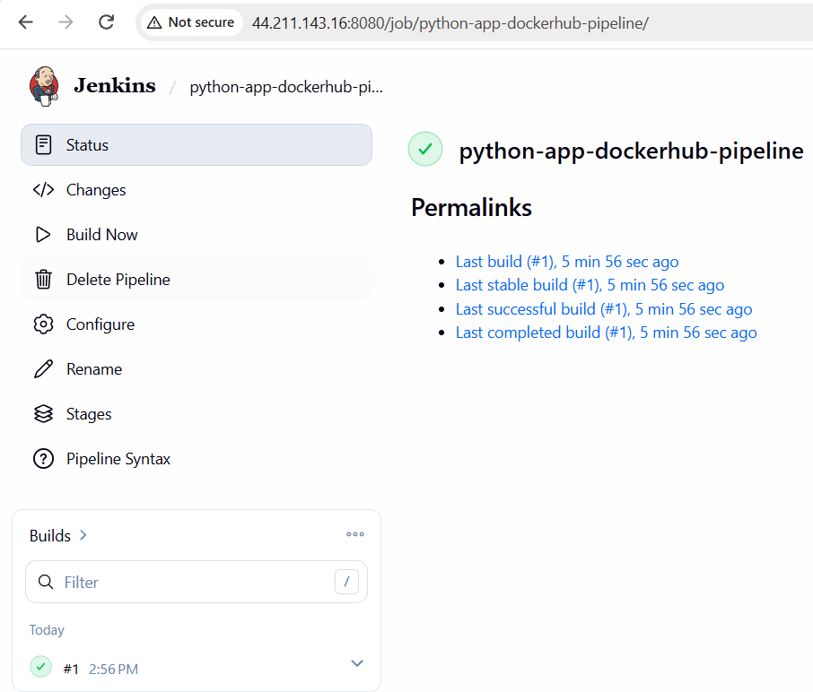
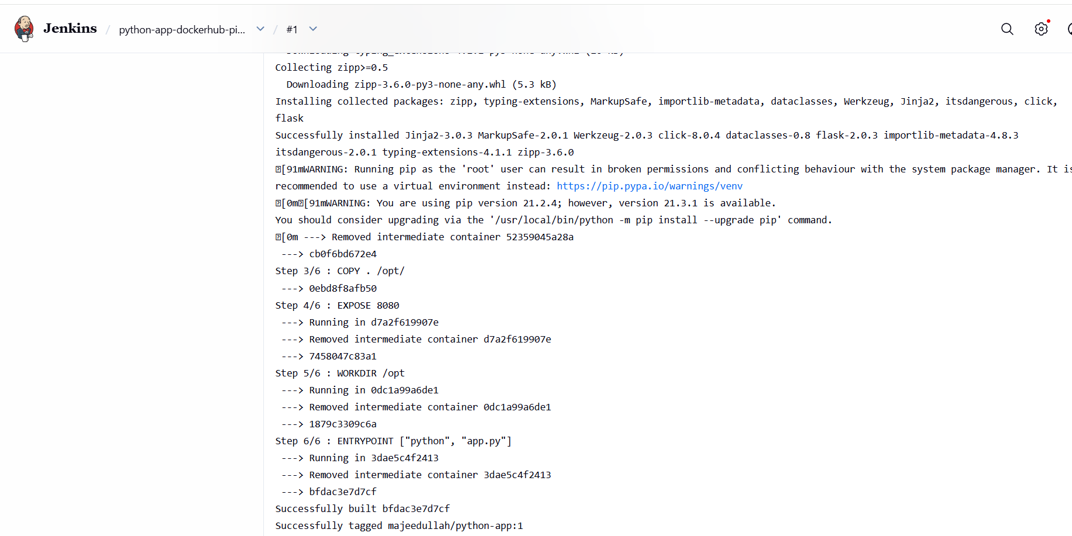
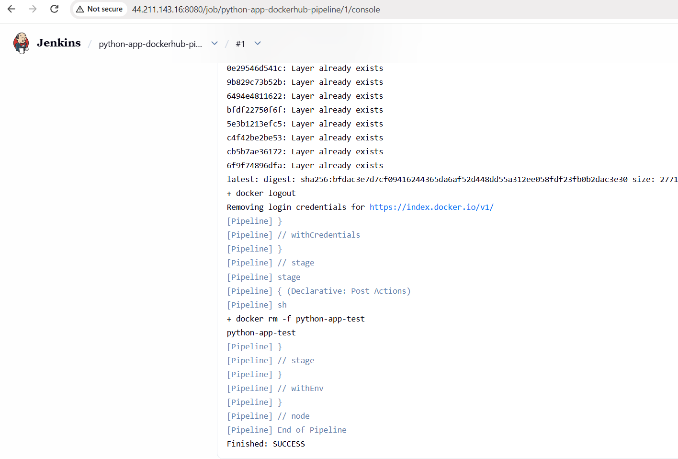
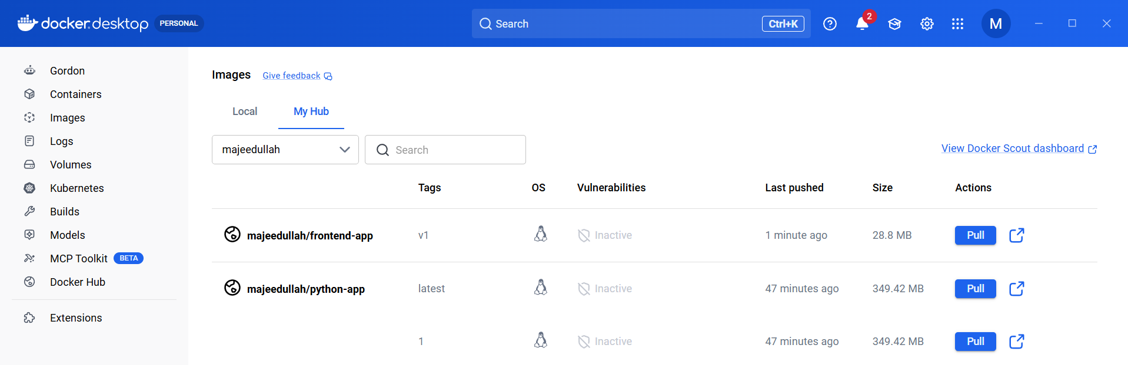

- From the frontend source code, write a Dockerfile, build a Docker image, run it, and push that image to your Docker registry.
- Source repository: docker-tasks
- Source files: index.html, javascript.js, style.css, todayDeal.js
- Goal: Create a Docker image that serves the frontend website using Nginx, run it, test it, and push it to Docker Hub.

Steps completed
Step | Action | Result
1 | Created /opt/frontend-app | Working directory ready
2 | Downloaded the source repository and copied frontend files | All four files present
3 | Created the Dockerfile | Nginx used to serve the website
4 | Built the Docker image | majeedullah/frontend-app:v1
5 | Started the container on port 8082 | Container running
6 | Tested using curl | HTTP 200 OK
7 | Opened the website in a browser | Amazon-style shopping page displayed
8 | Logged in to Docker Hub and pushed the image | Push succeeded

Dockerfile used
- FROM nginx:alpine

- COPY index.html /usr/share/nginx/html/index.html
- COPY style.css /usr/share/nginx/html/style.css
- COPY javascript.js /usr/share/nginx/html/javascript.js
- COPY todayDeal.js /usr/share/nginx/html/todayDeal.js

- EXPOSE 80

Main commands used
- mkdir -p /opt/frontend-app
- cd /opt/frontend-app

- git clone https://github.com/betawins/docker-tasks.git
- cp docker-tasks/Frontend_based_source/* .

- docker build -t majeedullah/frontend-app:v1 .

- docker run -d --name frontend-app -p 8082:80 majeedullah/frontend-app:v1

- curl -I http://localhost:8082

- docker login -u majeedullah
- docker push majeedullah/frontend-app:v1

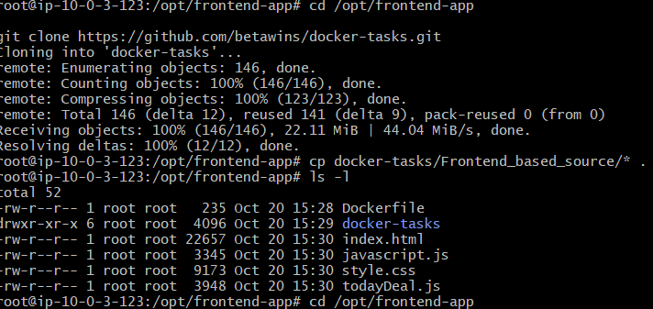
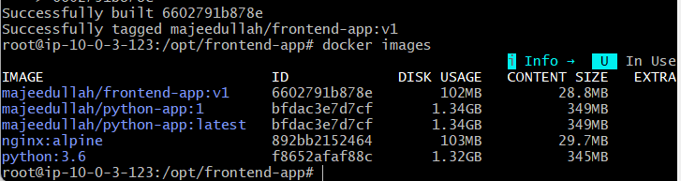
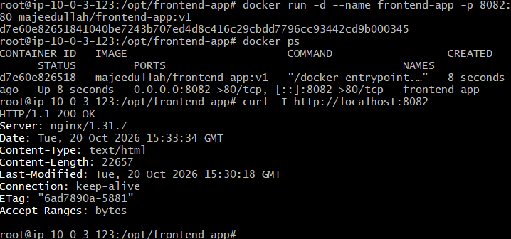
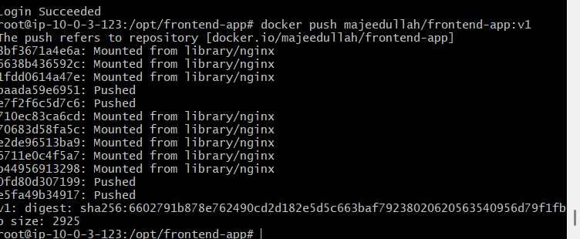
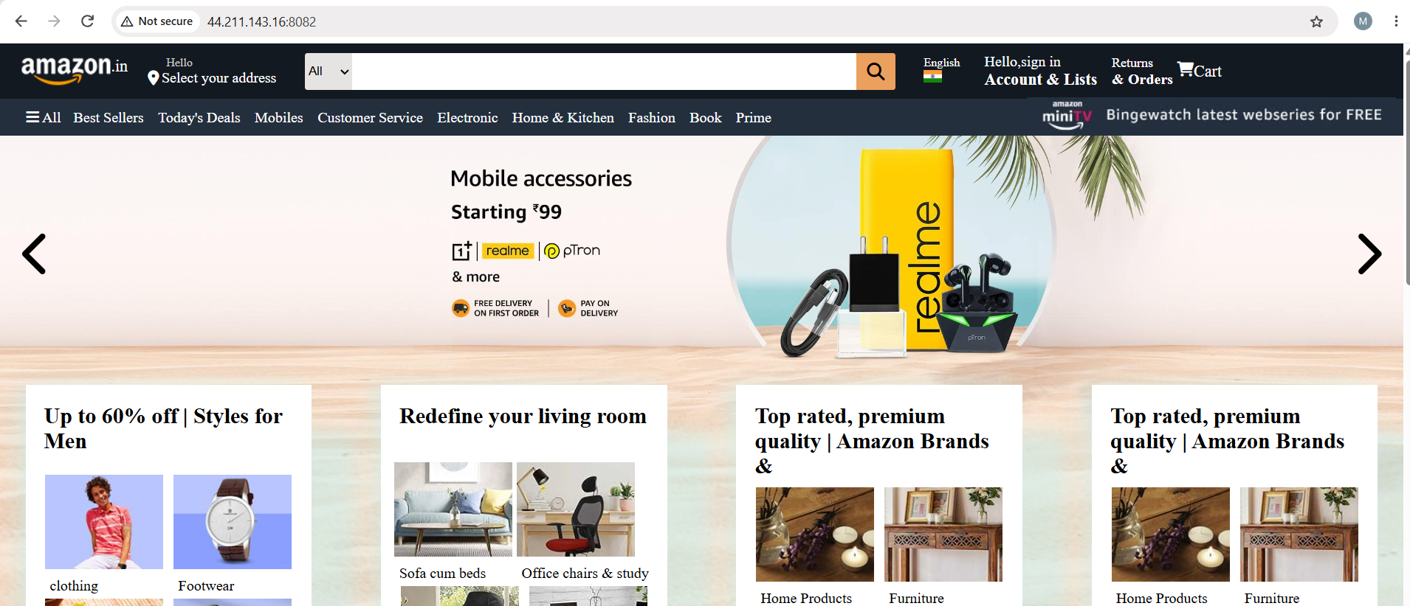
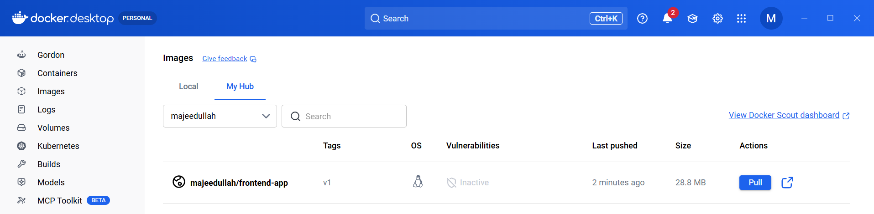

- From the Java-based source code, write a Dockerfile, build, run, and push the image to the Docker registry.

Steps performed
Step 1: Navigate to the Java project
cd /opt/docker-tasks/Java_based_source
Step 2: Create a Dockerfile
Created a multi-stage Dockerfile to build the Java application using Maven and run it with a lightweight Java runtime.
FROM maven:3.8.6-openjdk-11 AS build

WORKDIR /app
COPY pom.xml .
COPY src ./src

RUN mvn clean package -DskipTests

FROM eclipse-temurin:11-jre

WORKDIR /app
COPY --from=build /app/target/spring-boot-web.jar app.jar

EXPOSE 8080

CMD ["java", "-jar", "app.jar"]
Step 3: Build the Docker image
docker build -t majeedullah/java-app:v1 .
Step 4: Run the container
docker run -d --name java-app -p 8083:8080 majeedullah/java-app:v1
Step 5: Verify the container
docker ps
curl -I http://localhost:8083
The Java Spring Boot application serves the Techie Horizon — DevOps Training Institute website.
Step 6: Log in to Docker Hub
docker login -u majeedullah
Enter your Docker Hub access token when prompted. Do not share it.
Step 7: Push the image
docker push majeedullah/java-app:v1
The push completed successfully, and Docker Hub displayed the image digest.

Important notes
Concept | Explanation
Dockerfile | Contains instructions to build and run the application.
Multi-stage build | Separates the Maven build environment from the runtime image.
Maven | Compiles the Java code and packages it into a JAR file.
eclipse-temurin:11-jre | Provides the Java 11 runtime needed to run the application.
EXPOSE 8080 | Documents the port used by the application inside the container.
-p 8083:8080 | Maps EC2 host port 8083 to container port 8080.
docker build -t | Builds and tags the Docker image.
docker push | Uploads the image to Docker Hub.

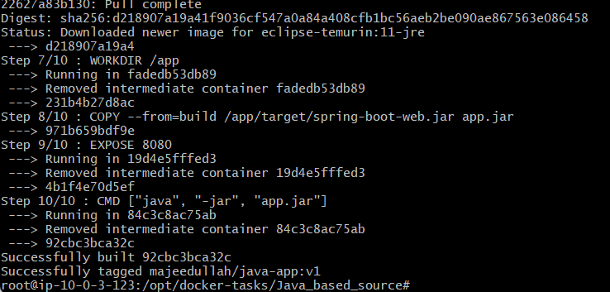
docker run -d --name java-app -p 8083:8080 majeedullah/java-app:v1
docker ps -a --filter name=java-app
docker logs java-app
curl -I --max-time 10 http://localhost:8083

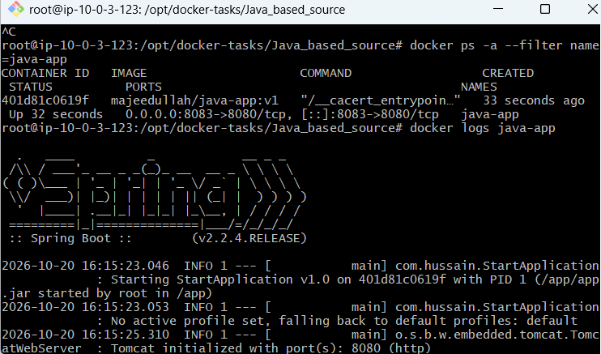
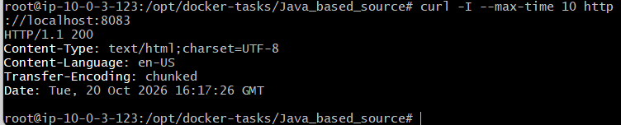
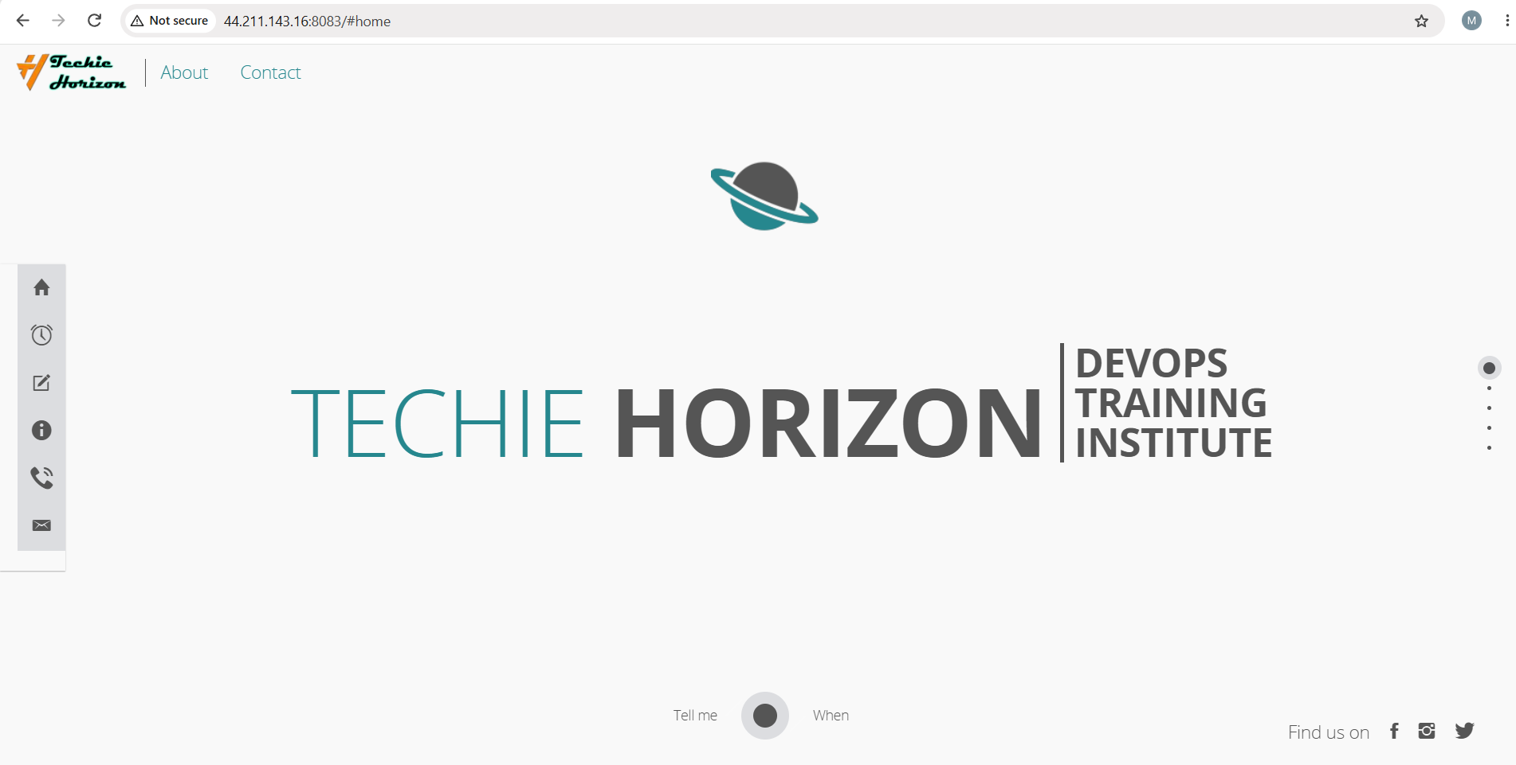
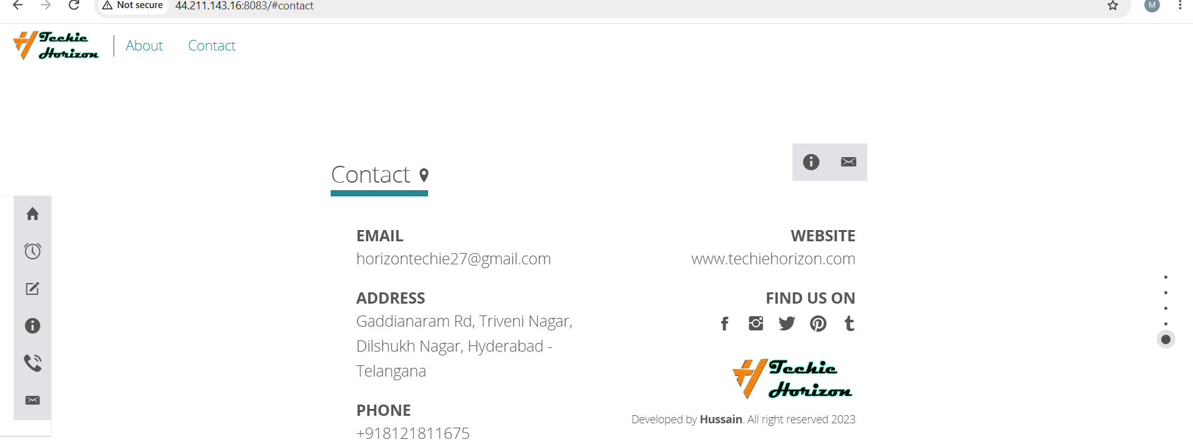
Push the image to Docker Hub
Run:
docker login -u majeedullah
Enter your Docker Hub access token when prompted. Then run:
docker push majeedullah/java-app:v1

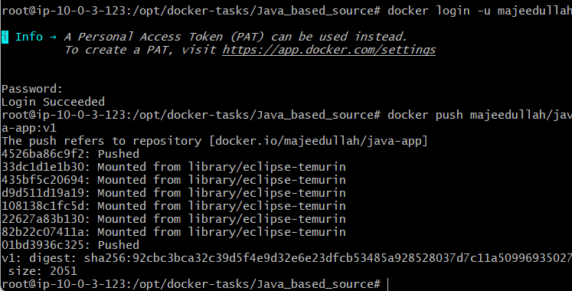
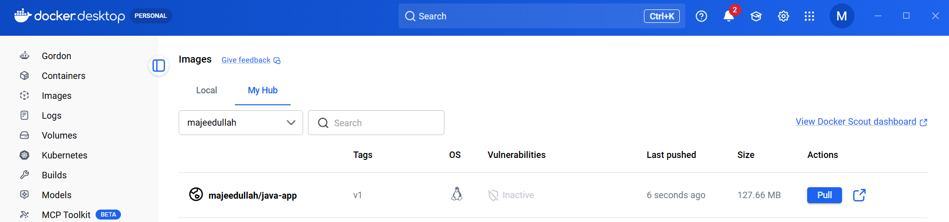
- From the Node.js-based source code, write a Dockerfile, build with tag v1, run, and push it to the Docker registry.
Steps and notes
Step | What we did
1. Inspect source | Checked package.json in NodeJs_based_source.
2. Create Dockerfile | Used a multi-stage build: Node.js builds React, and Nginx serves the production files.
3. Build image | docker build -t majeedullah/nodejs-app:v1 .
4. Run container | docker run -d --name nodejs-app -p 8084:80 majeedullah/nodejs-app:v1
5. Test application | Confirmed the Zomato-for-Patna page opened in the browser.
6. Log in | docker login -u majeedullah
7. Push image | docker push majeedullah/nodejs-app:v1 — Success
Important notes
- React is the frontend framework used by this application.
- npm run build creates optimized production files.
- Multi-stage build keeps Node.js build tools out of the final runtime image.
- Nginx serves the production website.
- Port mapping 8084:80 maps host port 8084 to container port 80.
- Docker Hub image: majeedullah/nodejs-app:v1
- Image size: 31.92 MB, as shown in Docker Desktop.
- Image digest: sha256:28904403f5dd9e4f81423f98871fd3f38c0c27011f8fe8405ddeabcb35cba94e
View Node.js image on Docker Hub

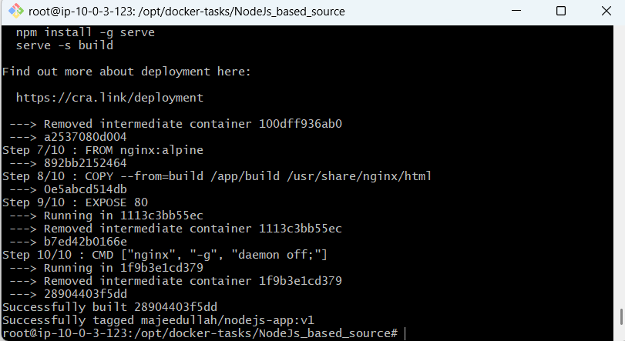

Push the Node.js image to Docker Hub
Since the Zomato-for-Patna page is open, let's push your image now.
1. Log in to Docker Hub (if you aren't already logged in):
docker login -u majeedullah
Enter your Docker Hub access token when prompted. Do not share it here.
2. Push the image:
docker push majeedullah/nodejs-app:v1

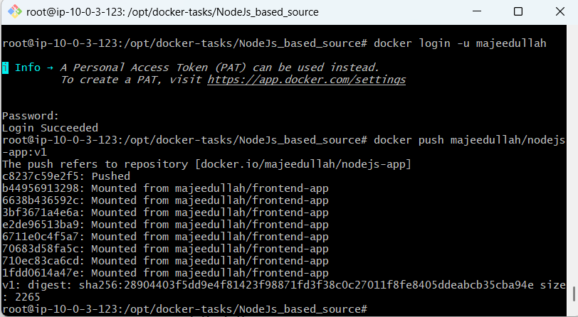
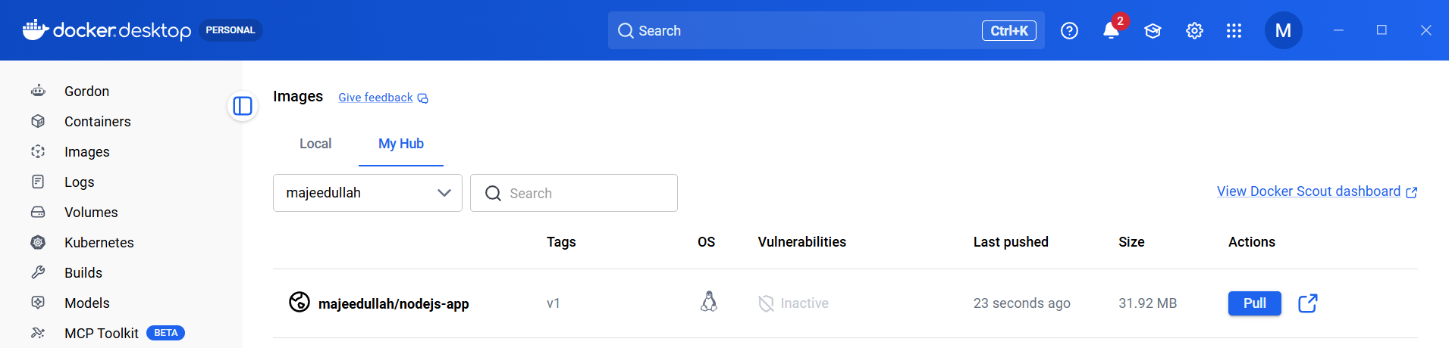

- Write a docker-compose file to set up WordPress with a MySQL database.
WordPress — the website, accessible on port 8085.
MySQL — the database that stores WordPress data.
Docker volumes — preserve website and database data if containers are recreated.

WordPress is a popular, open-source Content Management System (CMS). It helps people create websites, publish articles, add images, and manage website content through a dashboard.
For example, you can use WordPress to create:
- A business website
- A blog or news website
- An online shopping website
- A portfolio website
- An educational website
Objective
Deploy WordPress and its MySQL database using Docker Compose.
Steps
- Install Docker Compose
apt-get install -y docker-compose-v2
Verify:
docker compose version
- Create the project directory
- mkdir -p /opt/wordpress-mysql
cd /opt/wordpress-mysql
- Create the Compose file
nano docker-compose.yml
Define two services:
  - wordpress using wordpress:latest
  - db using mysql:8.0
- Configure environment variables
  - Database name: wordpress
  - Database user: wpuser
  - Set a database password and use the same password for WORDPRESS_DB_PASSWORD.
  - Set a separate MySQL root password.
- Configure ports and volumes
  - Map host port 8085 to WordPress container port 80.
  - Create db_data for MySQL data.
  - Create wordpress_data for WordPress files.
- Validate the configuration
docker compose config
- Start the services
docker compose up -d
- Verify the containers
docker compose ps
- Open WordPress
Visit http://<EC2-PUBLIC-IP>:8085, complete the WordPress installation, and log in to the dashboard.
Notes
- Docker Compose: Manages multiple related containers through one YAML file.
- WordPress: Application that runs the website.
- MySQL: Database that stores website content and settings.
- Environment variables: Configure the application and database.
- Docker volumes: Preserve data when containers are recreated.
- Port mapping: Makes WordPress accessible through the EC2 host on port 8085.
- Docker network: Allows WordPress to communicate with MySQL using db:3306.
Useful commands
docker compose ps
docker compose logs
docker compose logs wordpress
docker compose logs db
docker compose stop
docker compose start
docker compose down
Important: docker compose down removes the containers and network but normally preserves named volumes. Avoid docker compose down -v unless you intentionally want to delete the stored data.
Result
WordPress and MySQL were deployed successfully using Docker Compose. Both services started, and the WordPress admin dashboard was accessed through the EC2 public IP on port 8085.

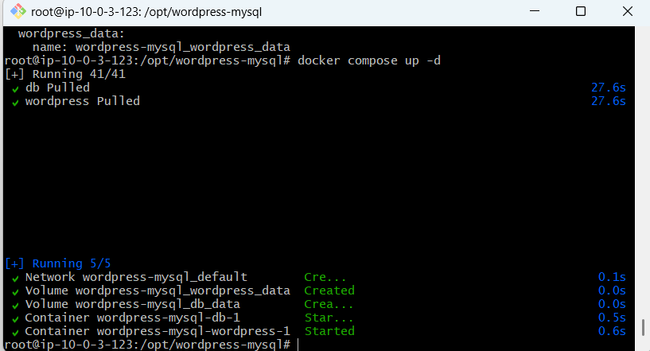
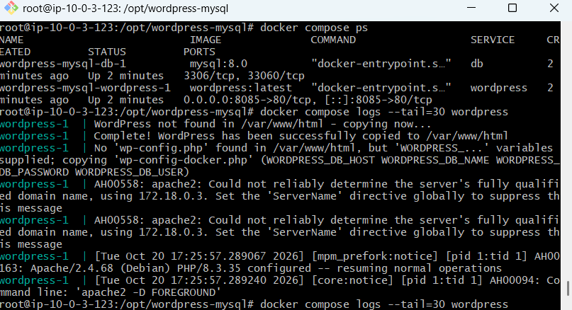
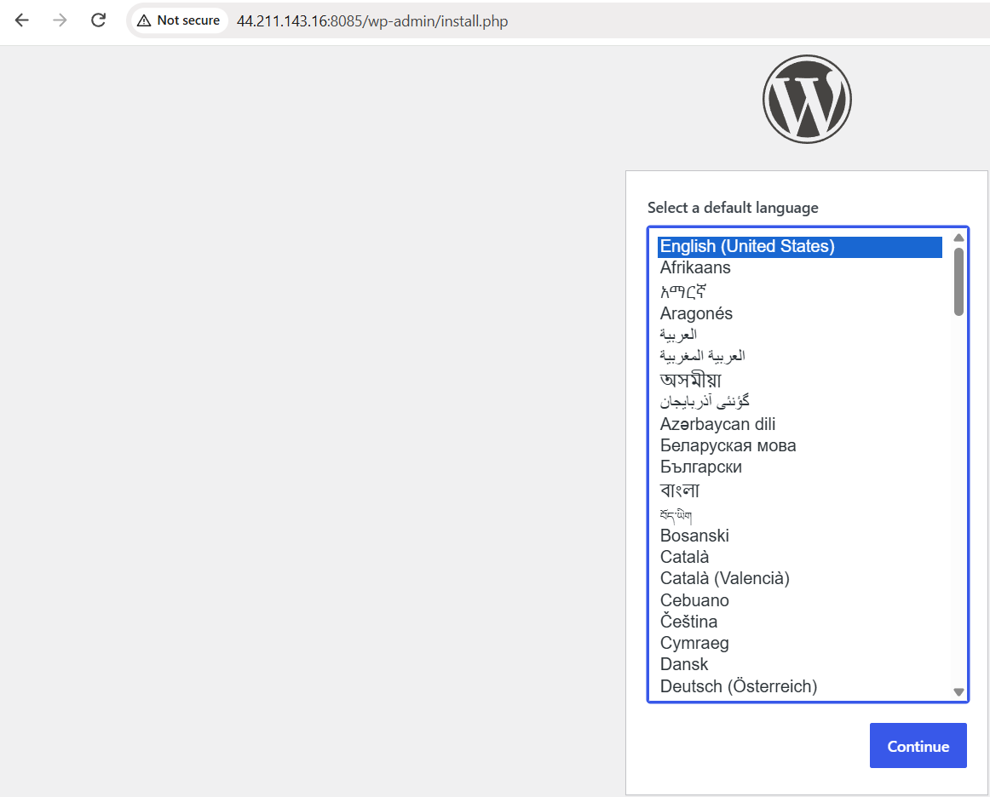
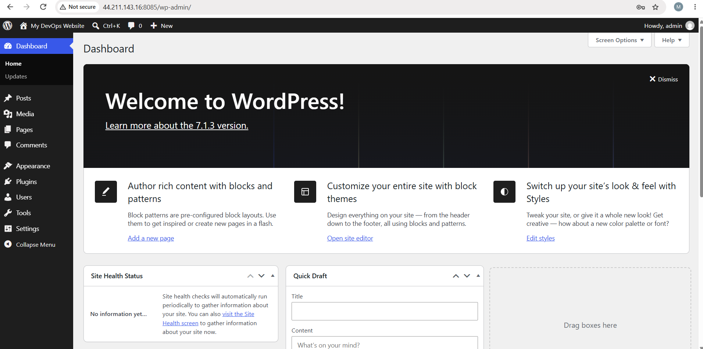
WordPress is an open-source Content Management System used to build and manage websites. In my Docker Compose lab, I deployed WordPress with a MySQL database, connected them through a Docker network, and used persistent volumes to retain data.”

